# Required Components

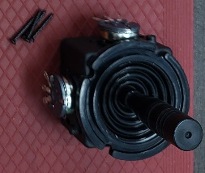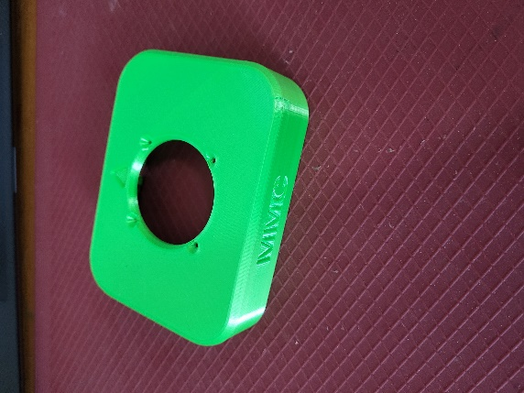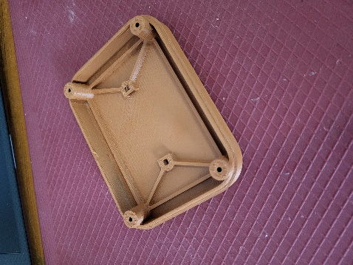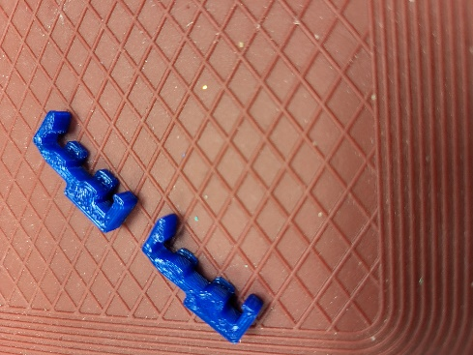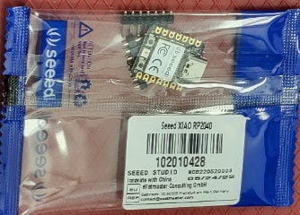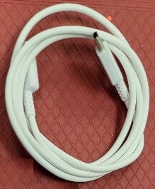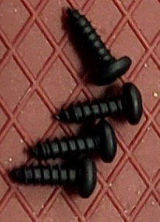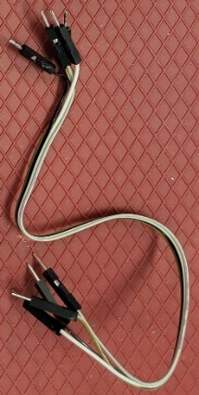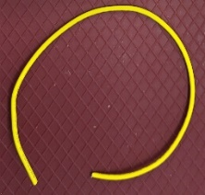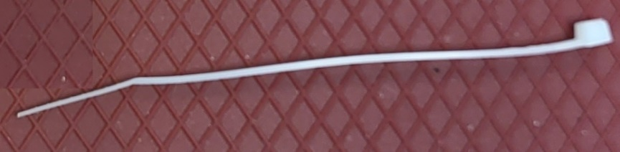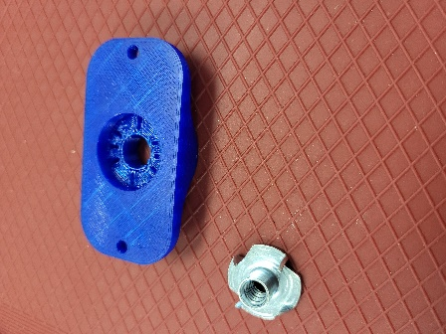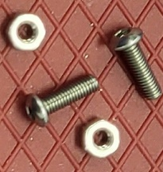

|  |  |
| --- | --- |
| 1. Adafruit mini analog joystick 2. 3D printed enclosure top 3. 3D printed enclosure bottom 4. 3D printed Microcontroller (MCU) mounts x2 5. Xiao RP2040 microcontroller 6. USB-c to USB cable 7. #4 3/8” screws x4 | 1. Male-male DuPont connectors x2 2. Extra 24 AWG wire 3. 4cm Zip tie 4. Optional materials 5. 3D printed camera mount adapter 6. Tee nut 7. M3x10mm screws x2 8. M3 nuts x2 |

# Required Tools

* Philips screwdriver
* Soldering iron and solder
* Superglue
* Wire Strippers
* ¼-20 hex bolt, at least 1/2'” long (Optional)

# Required Personal Protective Equipment (PPE)

* Safety goggles

# Assembly Instructions

## Step 1

Cut the DuPont cables in half and strip 2 cm from the cut end of each connector. Cut two extra wires, one to 5 cm and the other to 8 cm. Strip 2 cm from each end.

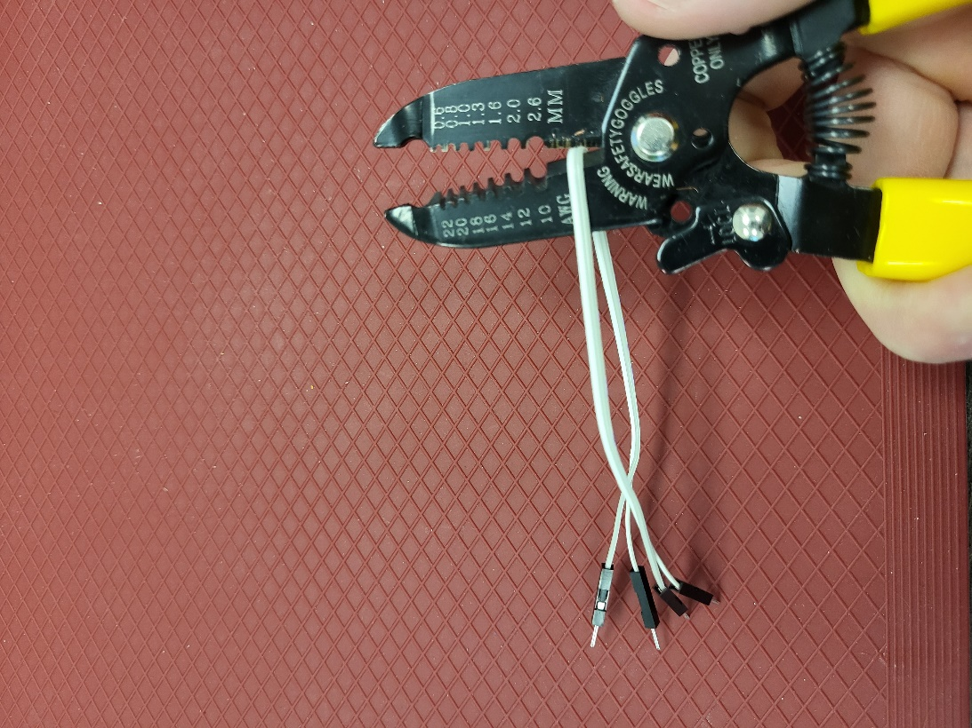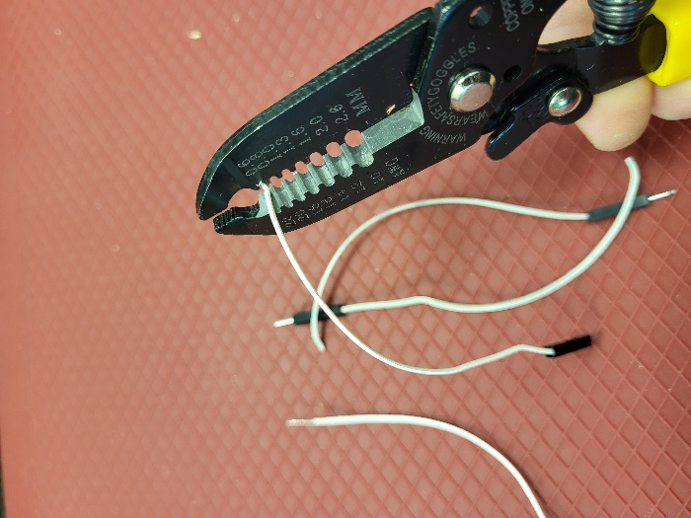

## Step 2

Twist the stripped end of two of the DuPont cables to the ends of the two extra wires, respectively.

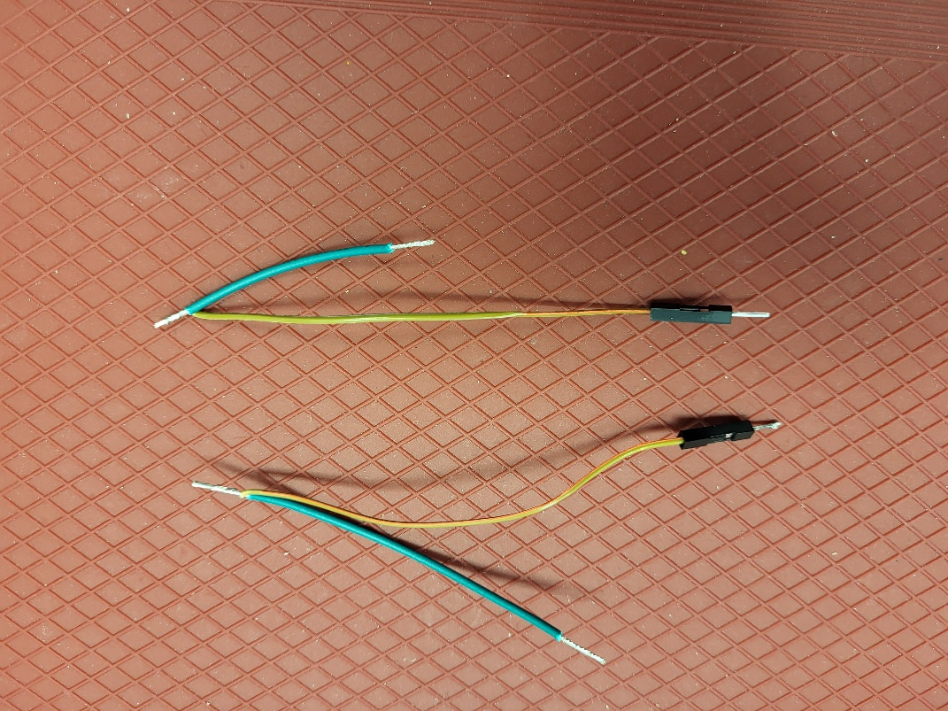

**NOTE**: You can also refer to the debosses in the top enclosure piece for wiring the joystick. (Steps 3-5)

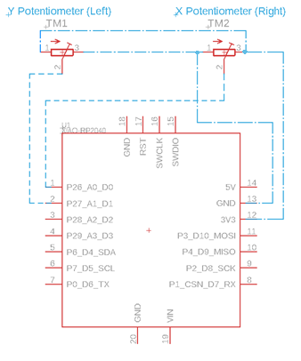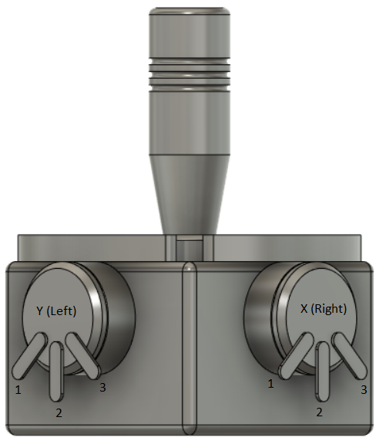

**·-·-· = Wire ---- = DuPont Cable**

**Image of Final Potentiometer Wiring**

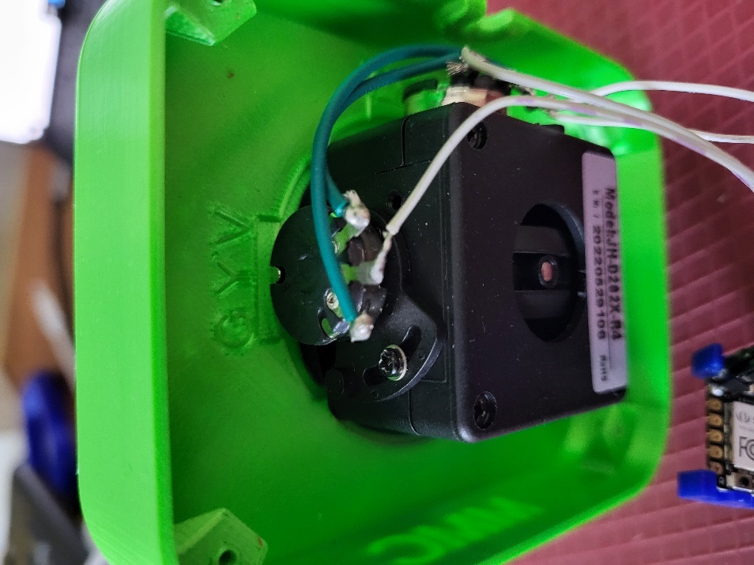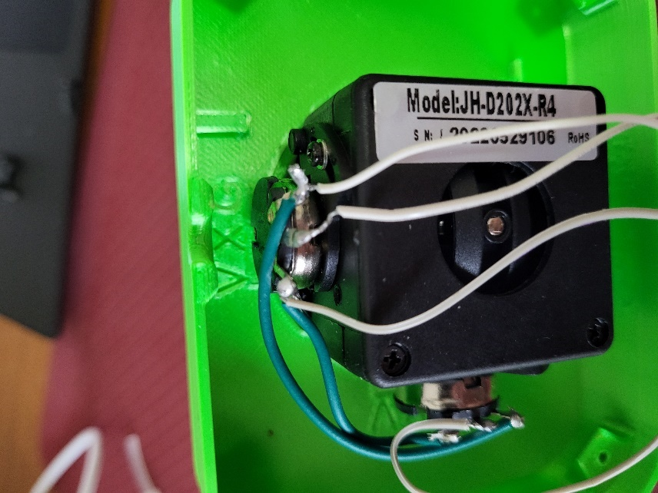

## Step 3

With the joystick oriented so the corner between the two potentiometers is facing you, solder the DuPont and 8 cm wire connection to the right most pin on the right-side potentiometer, and the DuPont cable and 5 cm wire connection to the left most pin on the right side potentiometer.

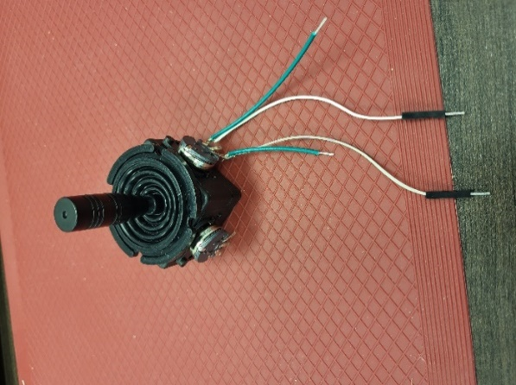 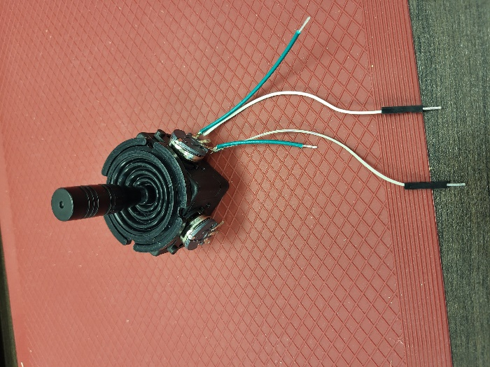

## Step 4

Solder the free end of the 8 cm wire to the left most pin on the left potentiometer, and the free end of the 5 cm wire to the rightmost pin of the left side potentiometer.

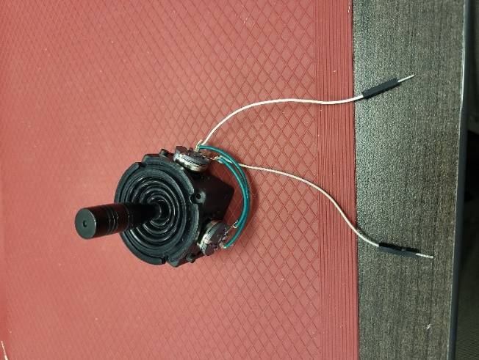 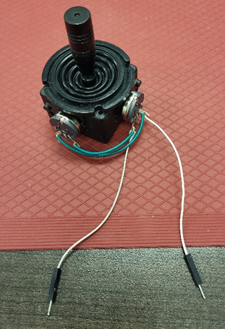

## Step 5

Solder the remaining two stripped DuPont cable ends to the remaining two potentiometer pins.

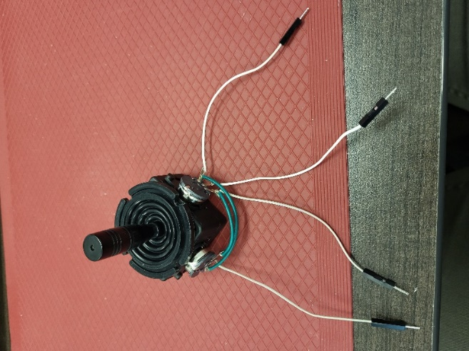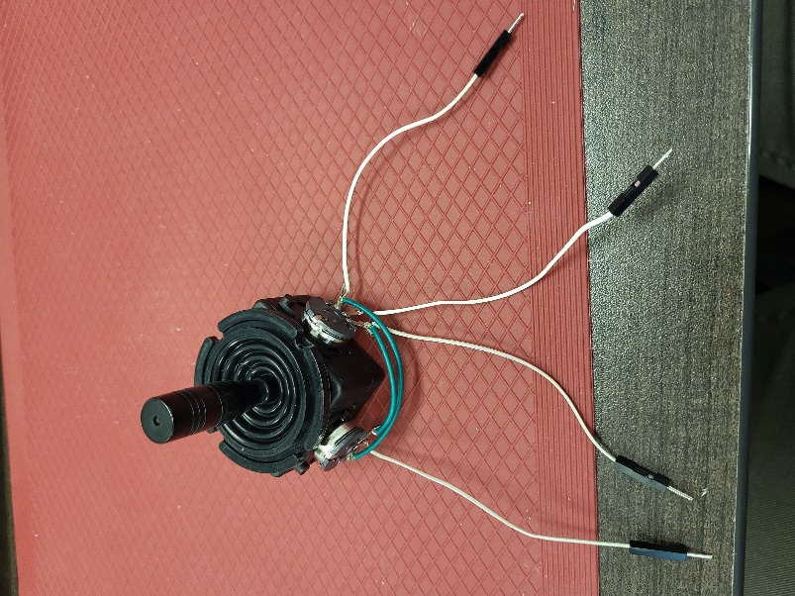

## Step 6

Using the screws that came with the joystick, screw the joystick into the top enclosure. Ensure the two rectangular debosses on the lid match with the potentiometers on the joystick.

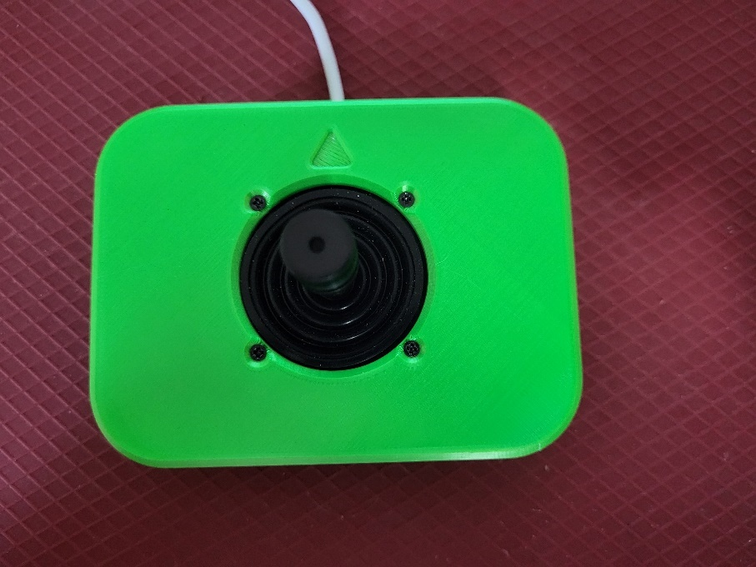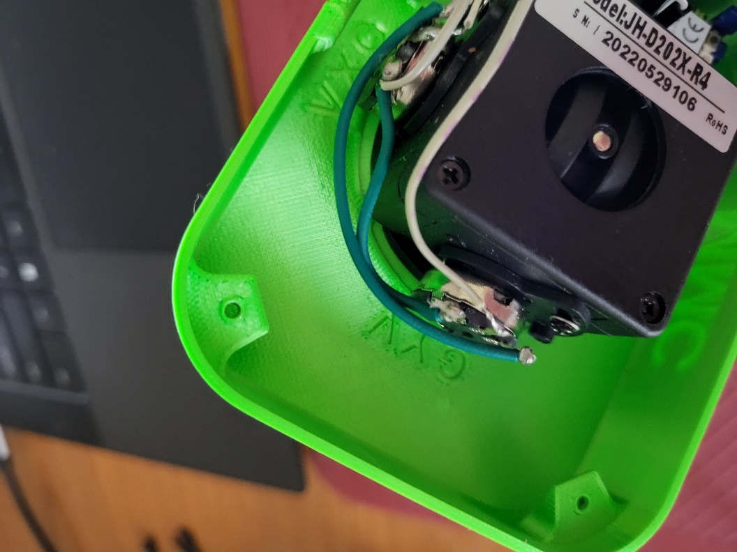

## Step 7

Place the XIAO RP2040 board into the microcontroller (MCU) mounts by sliding them over either end.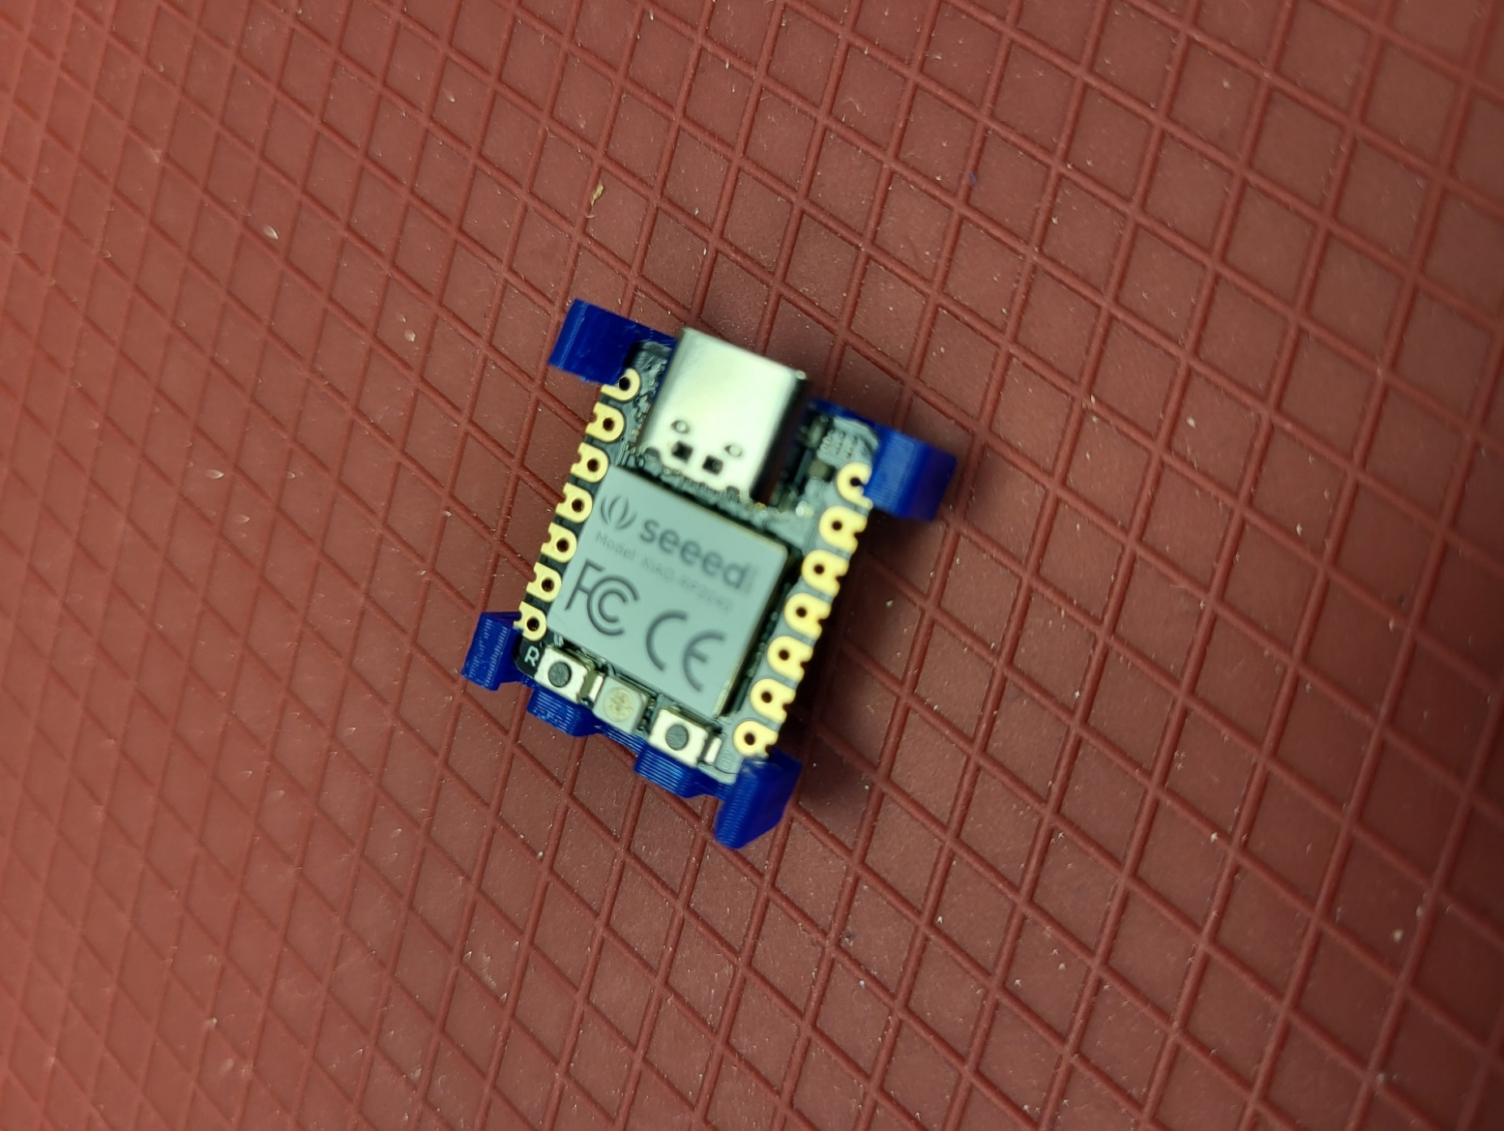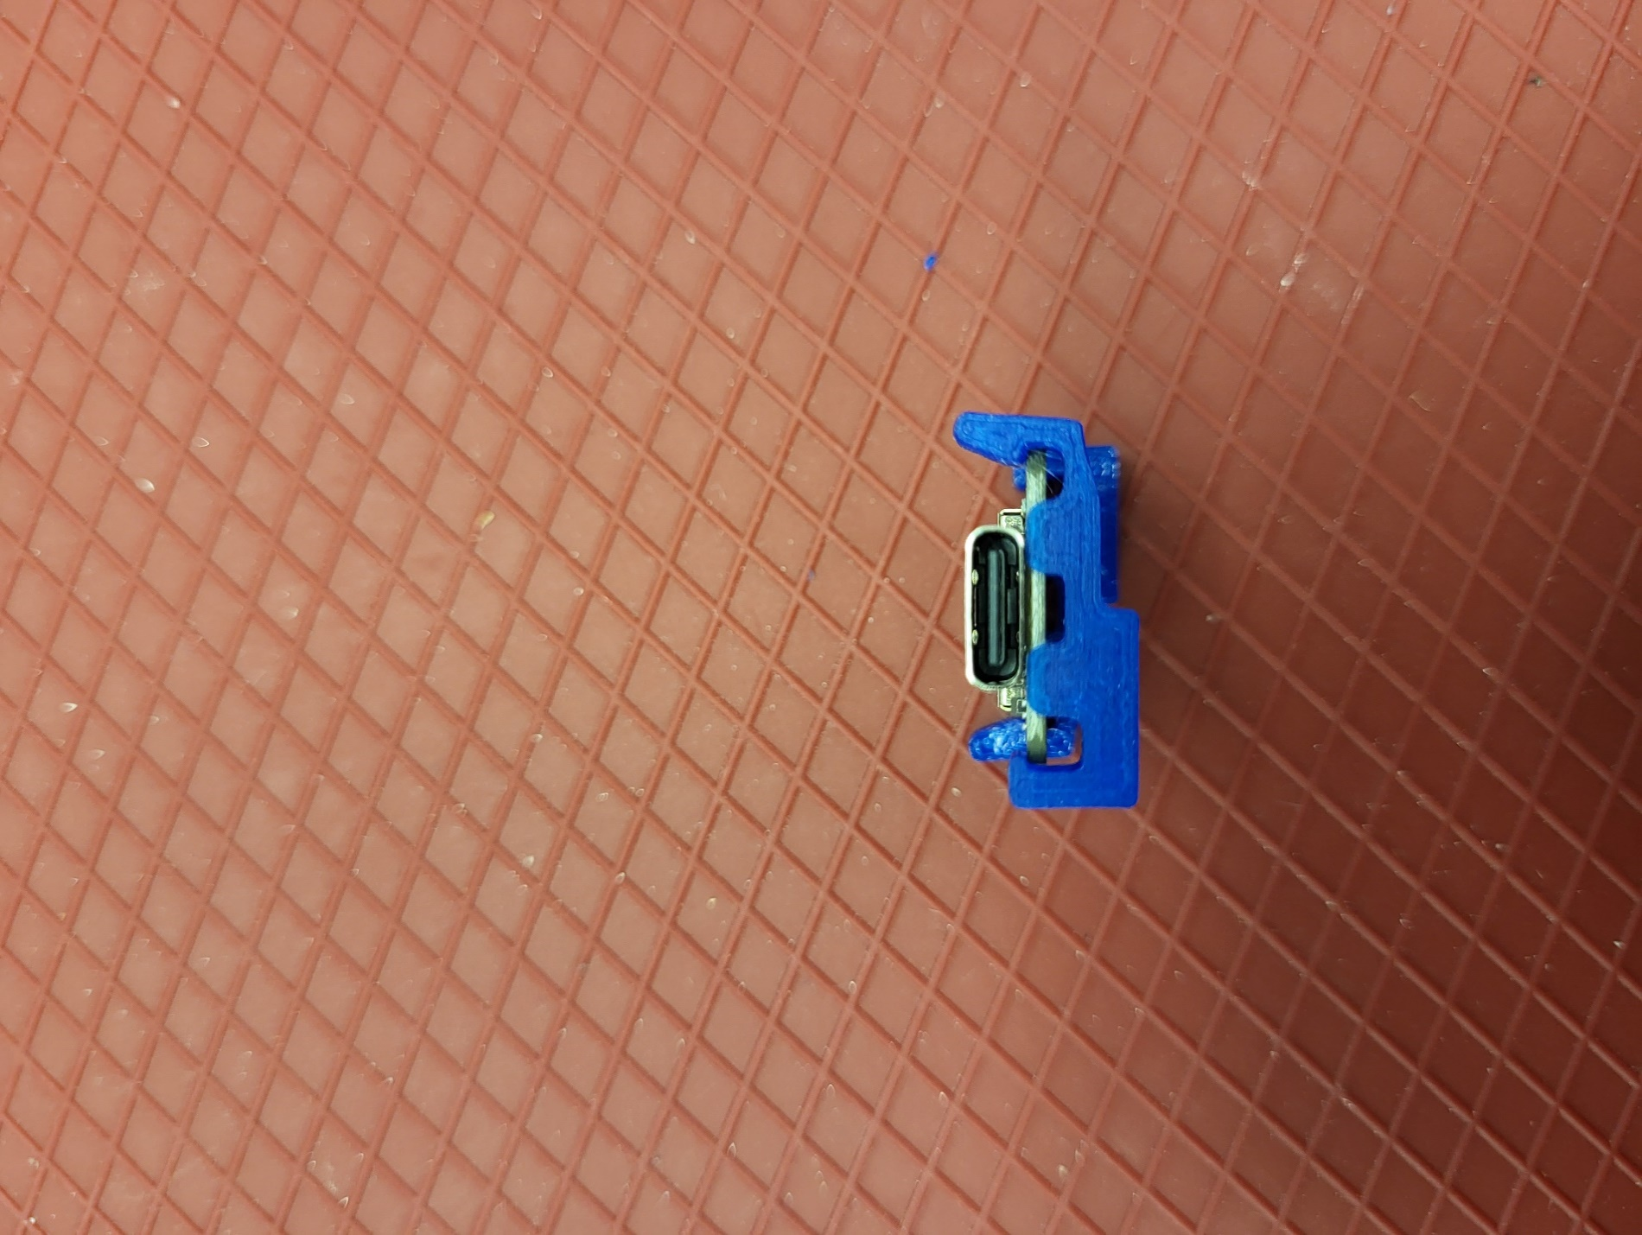

## Step 8

Solder the respective DuPont connectors to the microcontroller.

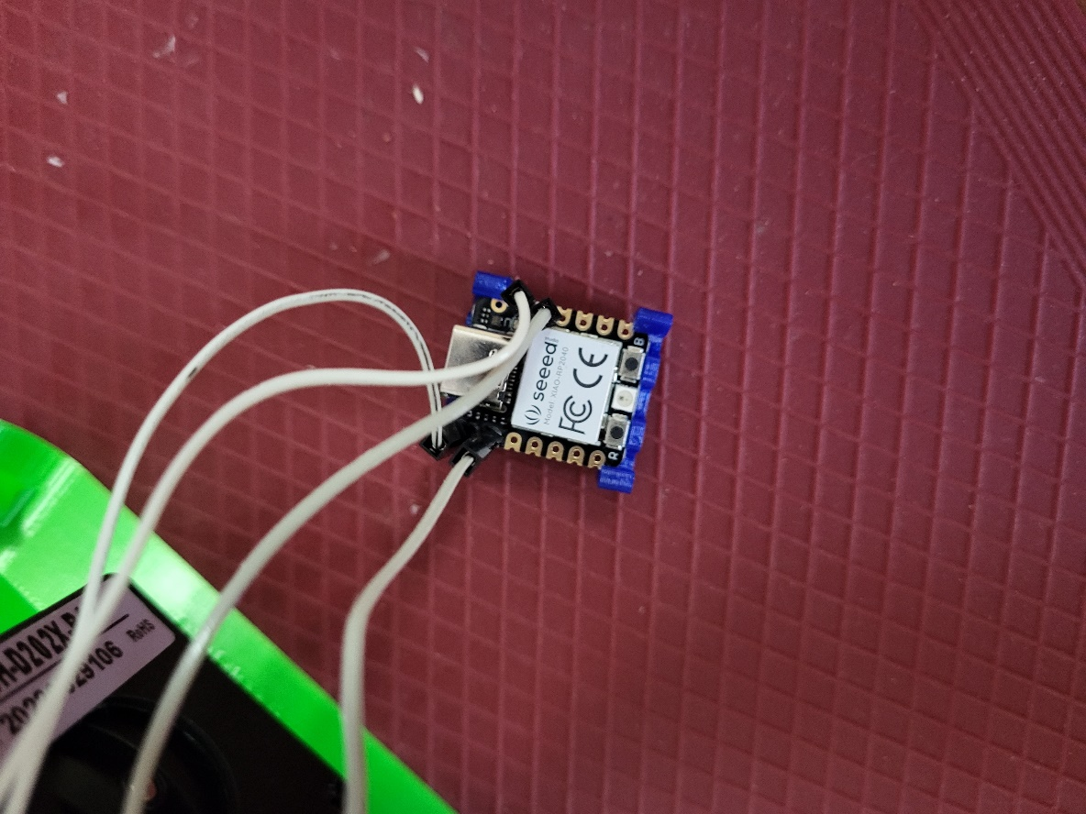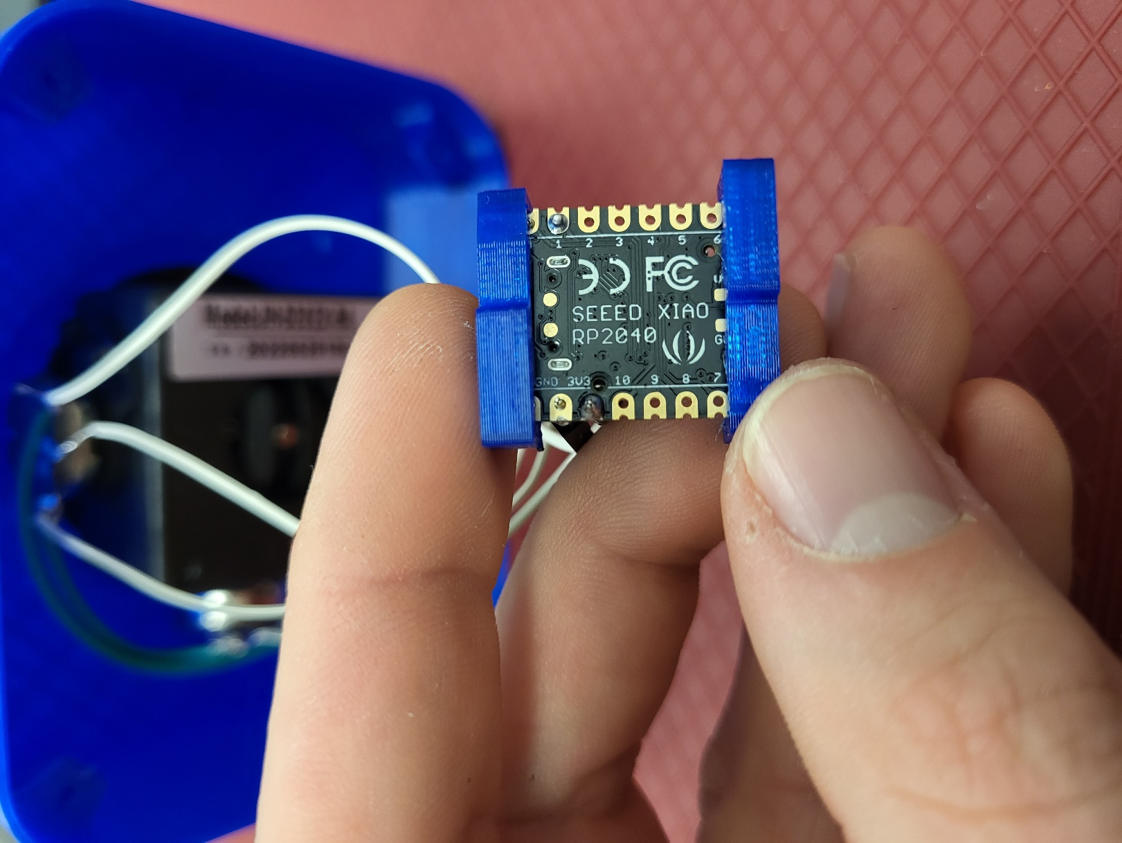

|  |  |
| --- | --- |
| Potentiometer Label | Microcontroller Pin |
| V | 3v3 |
| G | GND |
| X | A0 |
| Y | A1 |

## Step 9

Plug the USB-c cable into the XIAO RP2040 board and glue the microcontroller (MCU) mounts into place by applying glue to the bottom of the mounts and fitting into the corners protruding from the enclosure. Snugly attach a zip tie through the cable routing mount and around the cable. Cut the excess of the zip tie off.

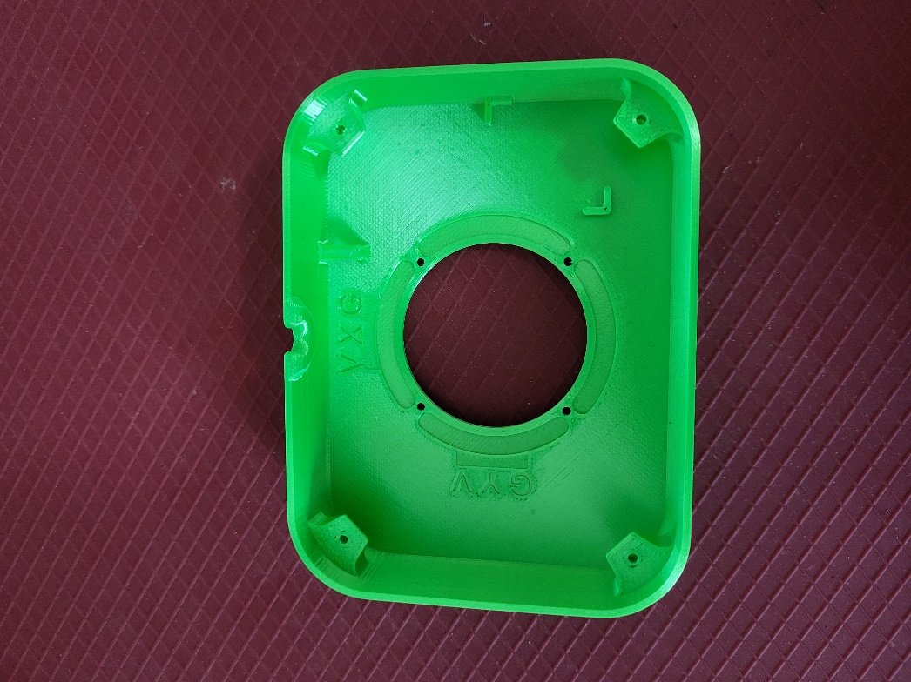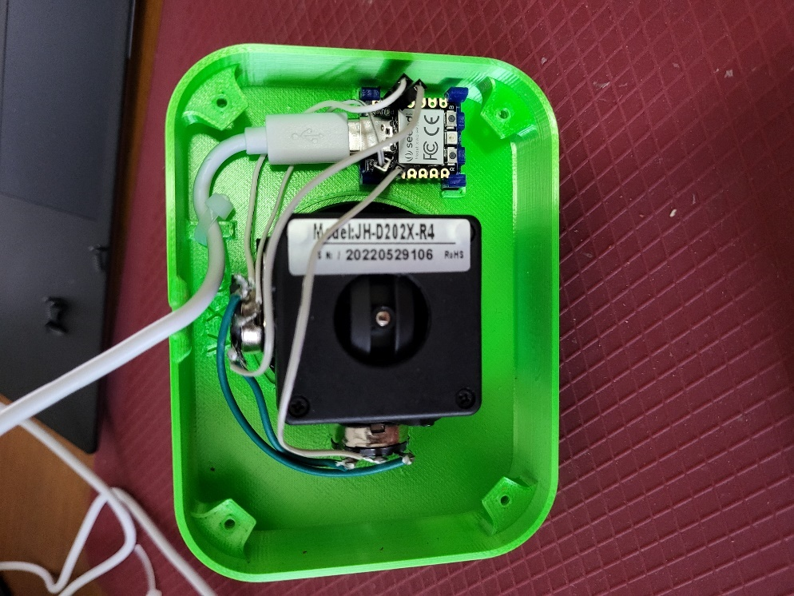

## Step 10

Slide the nuts into the slots in the bottom enclosure piece and screw the bottom enclosure to the top and you have your completed joystick.

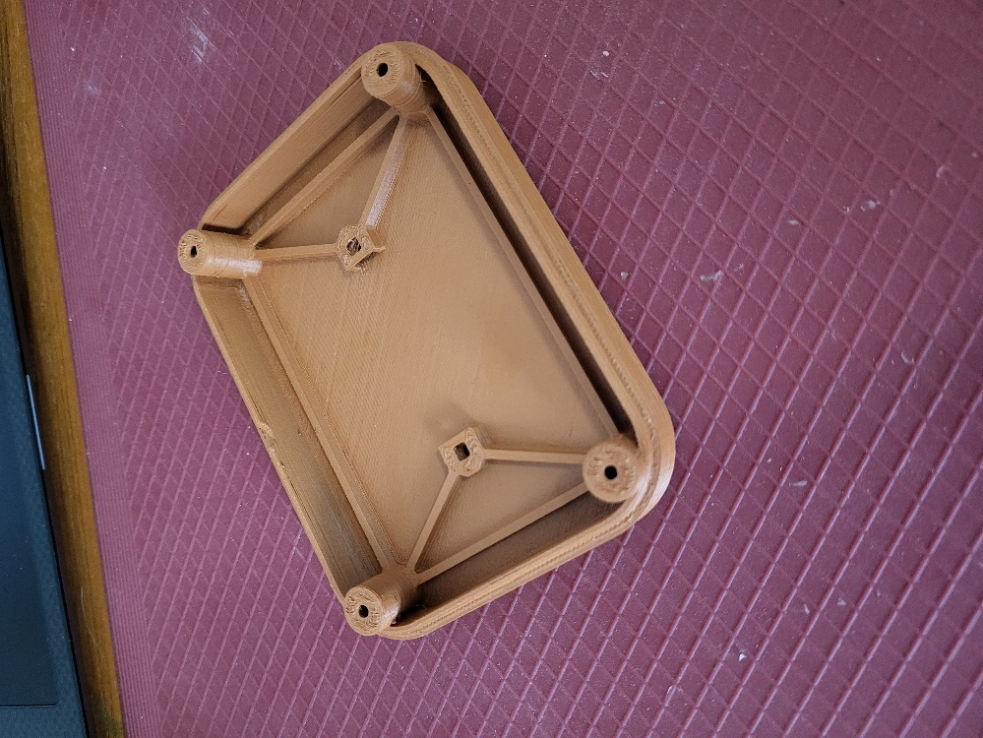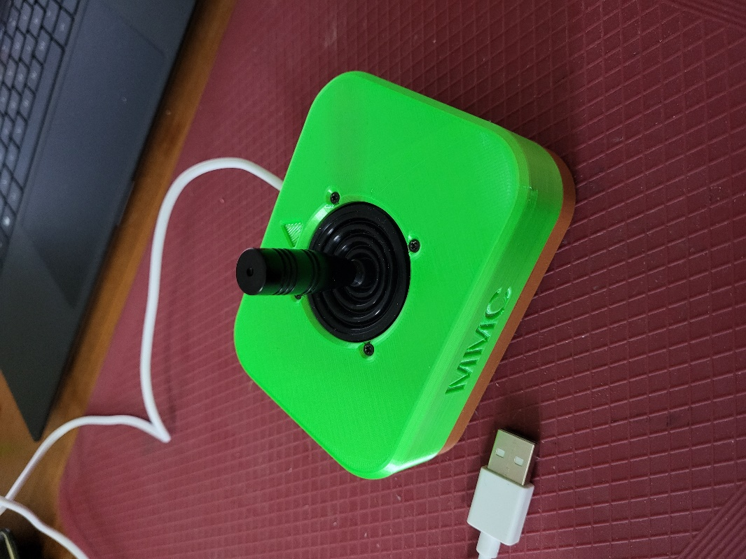

# Programming instructions

1. Setup Arduino IDE
   1. Download Arduino IDE for your operating system at <https://www.arduino.cc/en/software>
   2. Install Arduino IDE
2. Setup Core
   1. Open Arduino IDE
   2. Click on **File -> Preferences**
   3. Locate the text field that says **Additional Boards Manager URLs** beside it.
   4. Copy and paste the following link into the field as a new line: <https://github.com/earlephilhower/arduino-pico/releases/download/global/package_rp2040_index.json>
   5. Click on **OK**

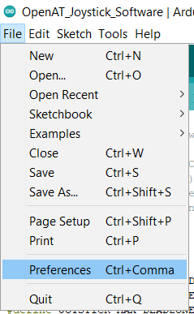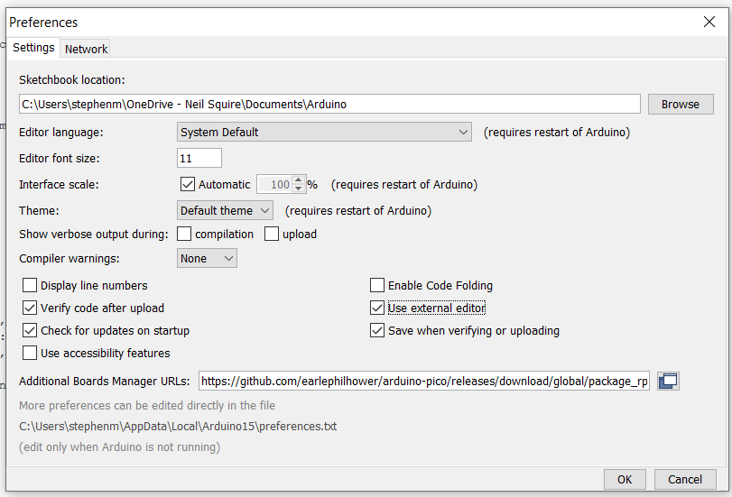

* 1. Restart the Arduino IDE
  2. Open the **Boards Manager** option from the **Tools-> Board-> Boards Manager..., search for “Seeed Xiao” and select the package called “Raspberry Pi Pico/RP2040” by Earle F. Philhower, III**

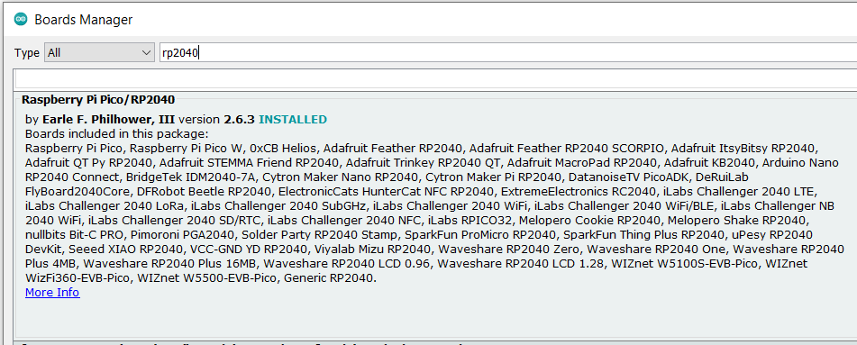

* 1. Select **Seeed XIAO RP2040** from **Tools -> Board** **-> Raspberry Pi RP2040** **Boards** menu.

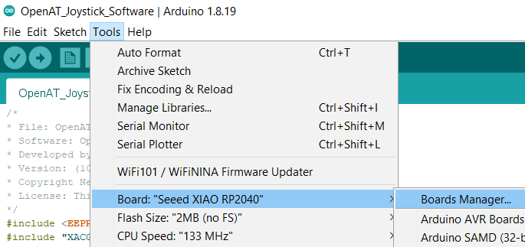

* 1. Click on **Tools -> USB Stack** and select **Adafruit TinyUSB**

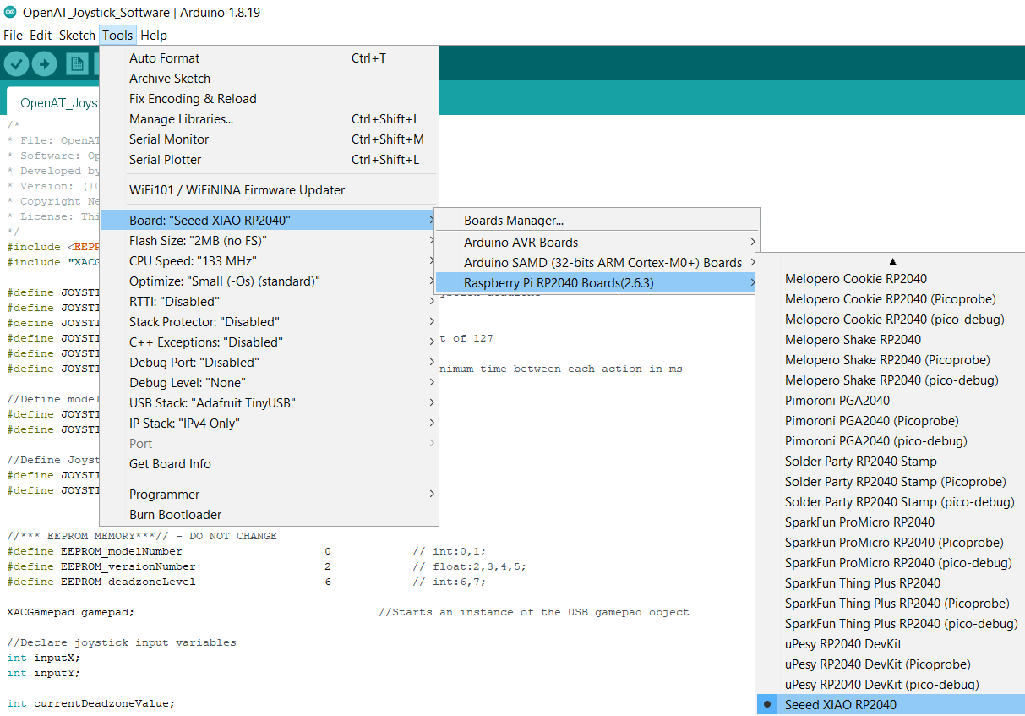

More Information: <https://wiki.seeedstudio.com/XIAO-RP2040-with-Arduino/>

1. Upload the Code to the joystick
   1. Open OpenAT_Joystick_Software.ino with Open Arduino ID.
   2. Select **Seeed XIAO RP2040** from **Tools -> Board** **-> Raspberry Pi RP2040** **Boards** menu.
   3. Connect the joystick using the USB cable to the computer.
   4. Select the correct port from **Tools -> Port** menu.
   5. Verify and upload the code.

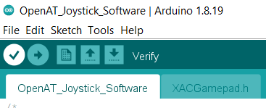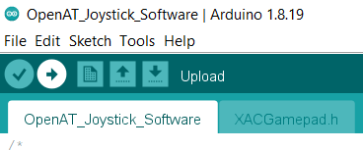

# Testing

1. Connect the joystick using the USB C cable to the computer.
2. If using Windows, open “Set up USB Game Controllers” from the Control Panel. You can find this by searching your computer in the search bar next to the Windows icon.
3. Ensure that the joystick is registered as a game controller and select your joystick from the list and go to “Properties”.
4. Move your joystick and observe the movement of the cross hatch in the “Axes” window. Ensure it moves in the proper directions when you move the joystick (the arrow points in the up direction). If not, open up the joystick and check your connections.

# Optional – Camera Mount

To mount the joystick on a camera mount, the optional Joystick Camera Mount Adapter can be used.

|  |  |
| --- | --- |
| Step 1 Flip the camera mount adapter around to reveal the recess with small slots.  Ensure all supports are removed from the 3D print. | Blue 3D printed part for the camera mount adapter. There are two holes on the sides and one hole in the middle with small slots around it. |

|  |  |
| --- | --- |
| Step 2 Insert the tee nut, lining up the barbs with the small slots in the 3D print. | Blue 3D printed part for the camera mount adapter, with a tee nut sitting inside of it, not fully inserted. |

|  |  |
| --- | --- |
| Step 3 Flip the part around and screw in a ¼-20 hex bolt. | Blue 3D printed part for the camera mount adapter, with a hex bolt being screwed into it. There is a white arrow showing to screw in the hex bolt clockwise. |

|  |  |
| --- | --- |
| Step 4 Tighten the bolt until the tee nut is seated down as far as possible. | Top of the camera mount adapter, with a hex bolt fully screwed into it. There is a white arrow showing to screw in the hex bolt clockwise. Bottom of the camera mount adapter, showing a tee nut fully installed into the 3D print, and sitting flush. There are two arrows pointing down to indicate that the tee nut is all the way down. |

|  |  |
| --- | --- |
| Step 5 Using 2 M3 screws, screw the camera mount adapter to the bottom of the joystick in the two middle holes. | The camera mount adapter screwed into the bottom of the Sliding Analog Thumbstick, using two small screws. Both the camera mount adapter and the joystick are light blue. The screws are circled in red. |